**LOGBOOK**

**Week One**

**3/10/2016 :**

Topics Covered: Basic physics, Arduino, Electronic concept, Soldering

Brief sum up:

Before coming to the hard(ware) part, we have been told about some physics concepts that concerns electricity and its properties.  
Periodic table is a table of all the (so far-discovered) elements findable in nature, all classified by three main properties: Atomic Number, Number of electrons the elements has on his orbits.  
This last is the one that more concerns us, because the number of negative subatomic particles is actually the one that states how stable is the element itself.  
In fact, if the element does not have “full” orbits, is more likely going to either receive or give electrons away.   
Metals usually get electrons from another source (elements), and to do so they create bonds with other elements, and is thanks to the Metallic bond that current can flow inside a metal.  
If we need to build circuits in which the current is going to flow, we might prefer to use conductors metals.

The current flowing in a wire made of metal, in an enclosed path and with a certain direction, is called “circuit”.  
In the circuit can be identified some properties: Intensity of the current ( *I* ), and the voltage (*V*).  
Ohm once stated that if we want to know the resistance(*R*) of the circuit, we just have to divide *I/V*.

We have then been taught how to build our own circuit and how to prevent a current overloading, just by setting up proper resistors.

To build an actual circuit the current must be able to flow through all the components, that’s why in the final step of an electric machine project, each “leg” of the components is soldered to a plastic board and then to another component.  
We have therefore been introduced to soldering, a third-year student briefly explained us how to do everything correctly. We also had a go trying.

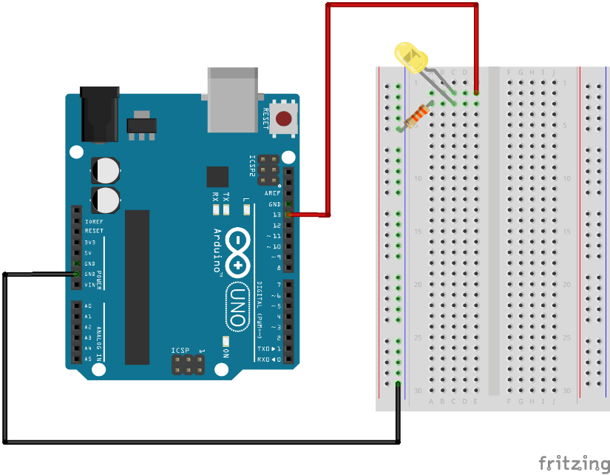  
  
Obviously during prototyping we can just use a plastic board with metallic stripes in the inside (breadboard), in which you can pin and unpin any component easily. We got started to Arduino IDE, Arduino Uno and Arduino Programming language.  
Catching them up quite quickly we produced our first project.

1:"Red wire is commonly used for positive, black for negative.

Pin 13 is just a selected energy source (5v)"

***FIRST ARDUINO CODE***

Soldering

Things to remember for soldering:

Keep the board flat before start soldering

Remember to put all parts in right way

Make a nice pick on the actual soldered element

Don’t touch the point of the soldering machine, NEVER

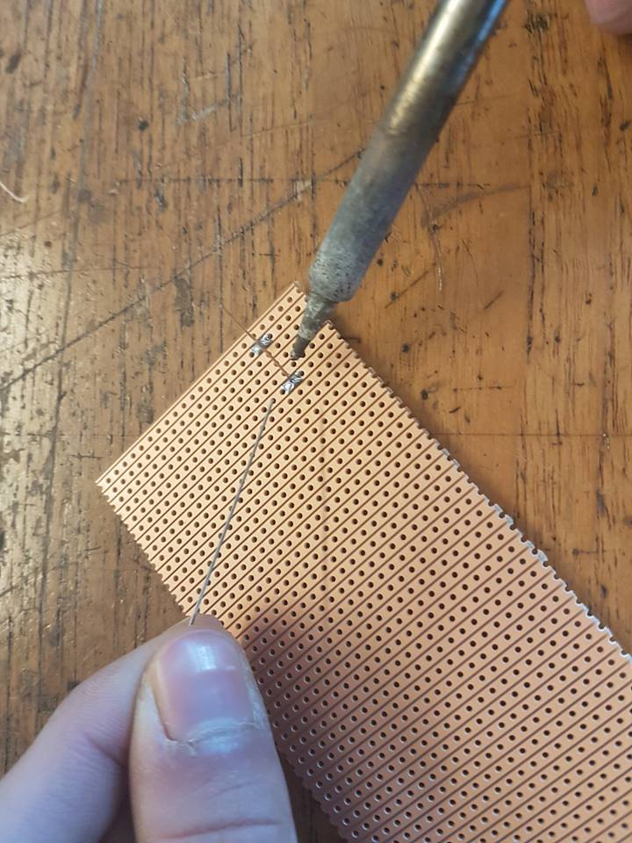 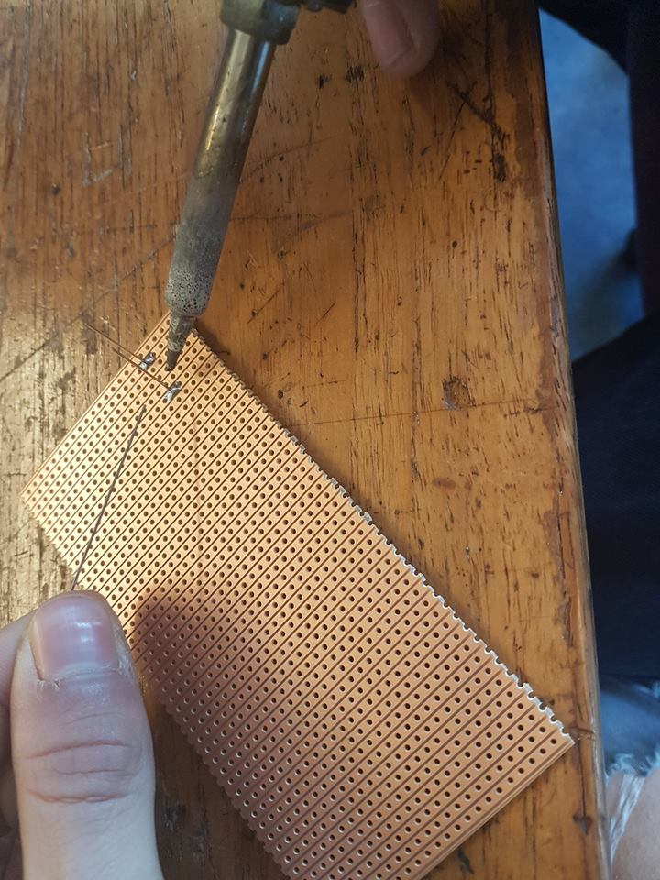

**Week Two**

**10/10/2016 :**

Topics Covered: Arduino, Electronic circuits logic and components (BUTTONS)

Brief sum up:

A zero-component circuit would be ideally composed by an energy supplier (which is usually a battery or a plug or (as in our case) an Arduino) and then a wire which connect the positive pole of the source to the negative one.  
Along the way of this ideal circuit we can place many objects which are going to be our circuit’s  
components.

Beyond the two legs components (Resistors, Capacitors, LED ecc.), there are many other pieces which require more than just one positive (energy in) and one negative (energy out ->Ground).  
Buttons have four legs, and need two energy suppliers, one from the Arduino to read data, and one from a 5v Arduino exit.  
It was our task to wire up a circuit in which a led would have turned on/off, the all decided by a buttonpress.

The way we approached this: Putting stuff together from last lesson we figured out we first needed a circuit for LED and then by logic we just needed to attach the power-in leg to the button, as the button could then handle the whole flow of current.  
Simply doing that didn’t help, because the real struggle was figuring out how to create the circuit for the button, which (as I just said) takes in two positive, this took us a while to be fully understood.

Ctrl+click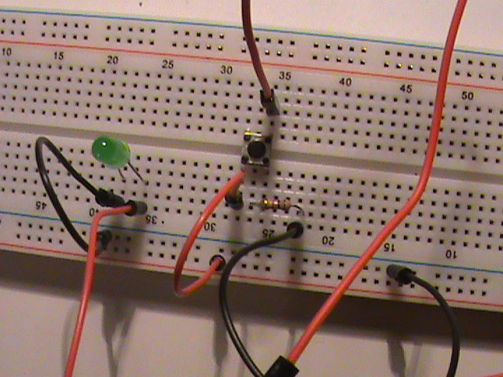 for gif

After achieving the one led blink, there was still the final task to be maid, make two leds blinking with two different buttons and crack the code a bit to turn led on till next button-press:

Modules and elements used:

-Two buttons  
-Two LEDs  
-Two 1k resistors

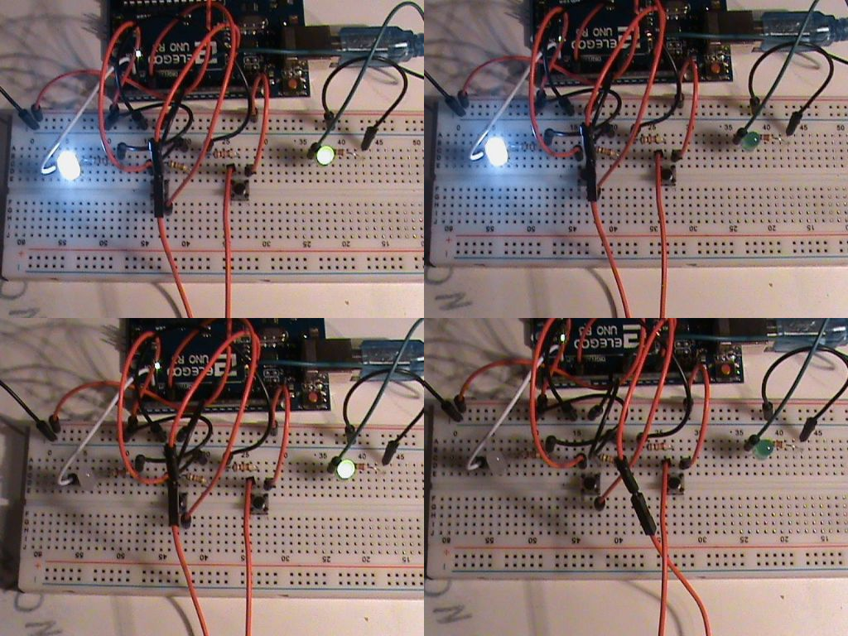

Better Resolution:

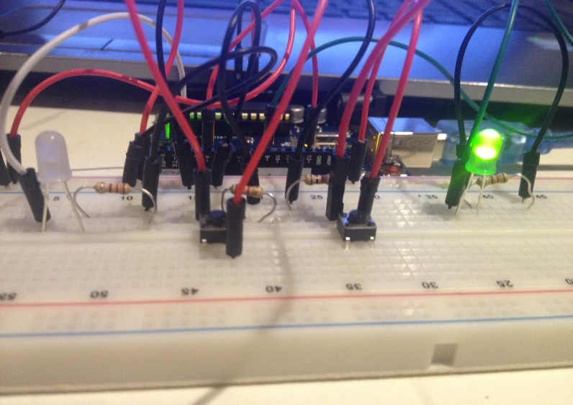

Code is the following: 



|  |  |
| --- | --- |
| **Week** | 8 |

**Week Three**

**17/10/2016 :**

Today the first analog element has been introduced: a potentiometer!  
Analog means something that can’t be measured by a computer and more likely is going to be translated in numbers to be understood by any kind of machine. When we were talking about digital we were simply referring to numbers and values.

A potentiometer is a three-terminal resistor with a sliding or rotating contact that forms an adjustable voltage divider. If only two terminals are used, one end and the wiper, it acts as a variable resistor or rheostat.  
The measuring instrument called a potentiometer is essentially a voltage divider used for measuring electric potential (voltage); the component is an implementation of the same principle, hence its name.

We are going to be using a piezo passive buzzer as well, this can produce a sound which can be modified by the Arduino,  
The tone change whenever a different current frequency is sent to it.  
The difference between an active and a passive buzzer is that the first one can generate the tone by its own (so just needs the user input to be on and off), while the second one needs the Arduino to send specified signals to it so then they can be interpreted and reproduced as music/sound.

Another element introduced is the photoresistor (or light-dependent resistor, **LDR**) is a light-controlled variable resistor. The resistance of a photoresistor decreases with increasing incident light intensity; in other words, it exhibits photoconductivity. This feature can allow you to change another sensor-value accordingly to the quantity of light in the room.

Task 1:

Modules and elements used:

-Arduino uno board  
-Bunch of wires  
-three leds  
-Potentiometer  
-120r Resistors

VIDEO

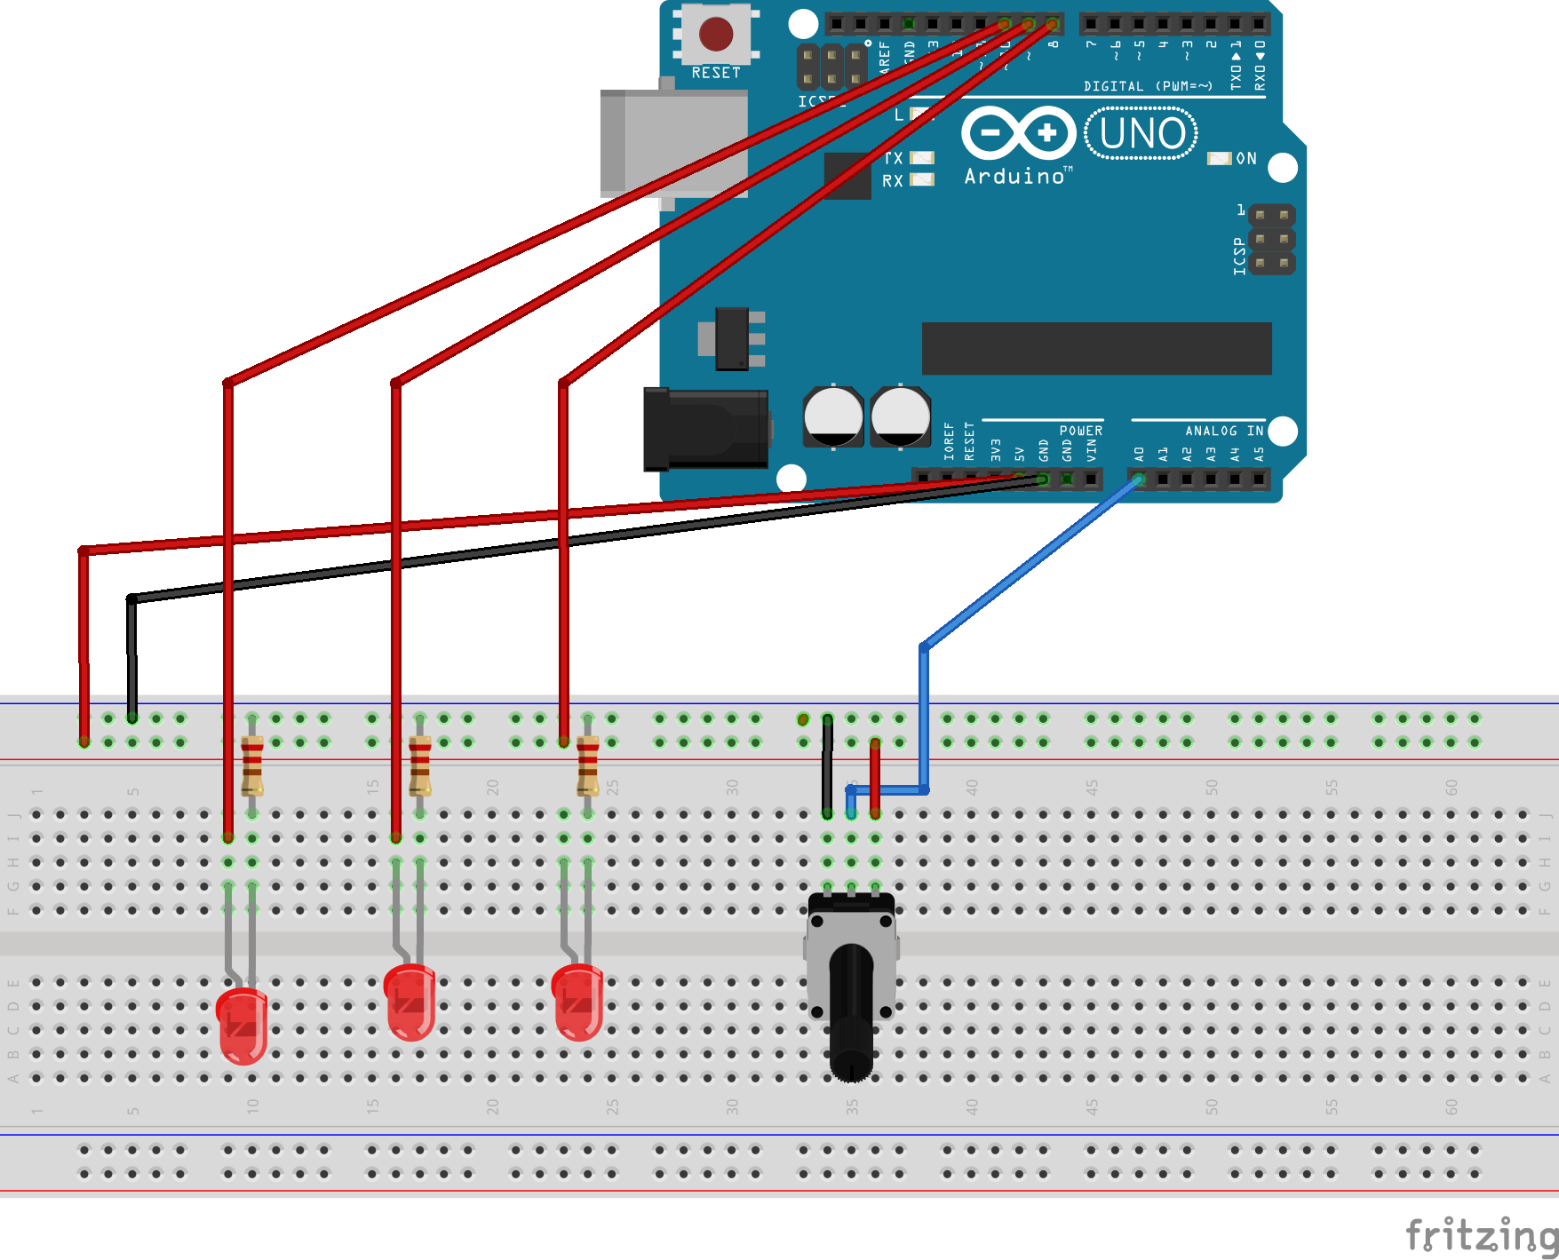

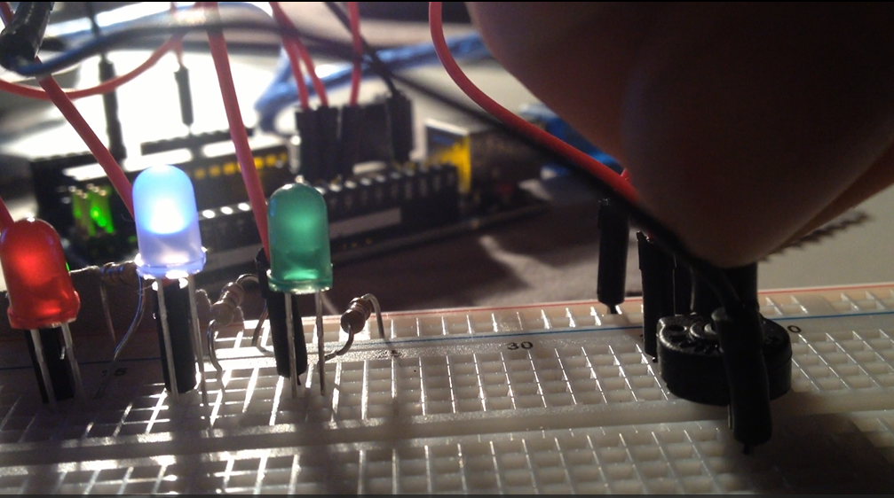

Arduino code:

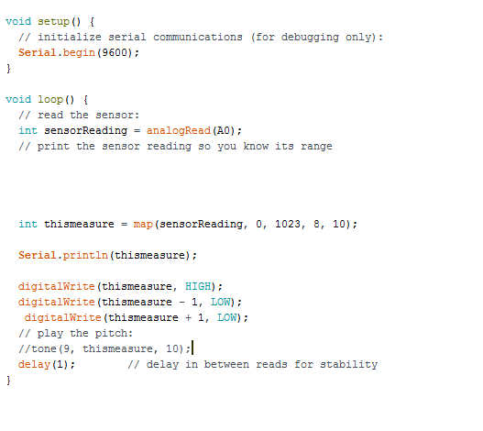

*Here I’ve mapped the analog value between the number of pins involved (8,9,10) and turned them on consequently.*

Task 2:

Modules and elements used:

-wires  
-10k and 125r resistors  
-piezo passive buzzer  
-photoresistor (photocell)

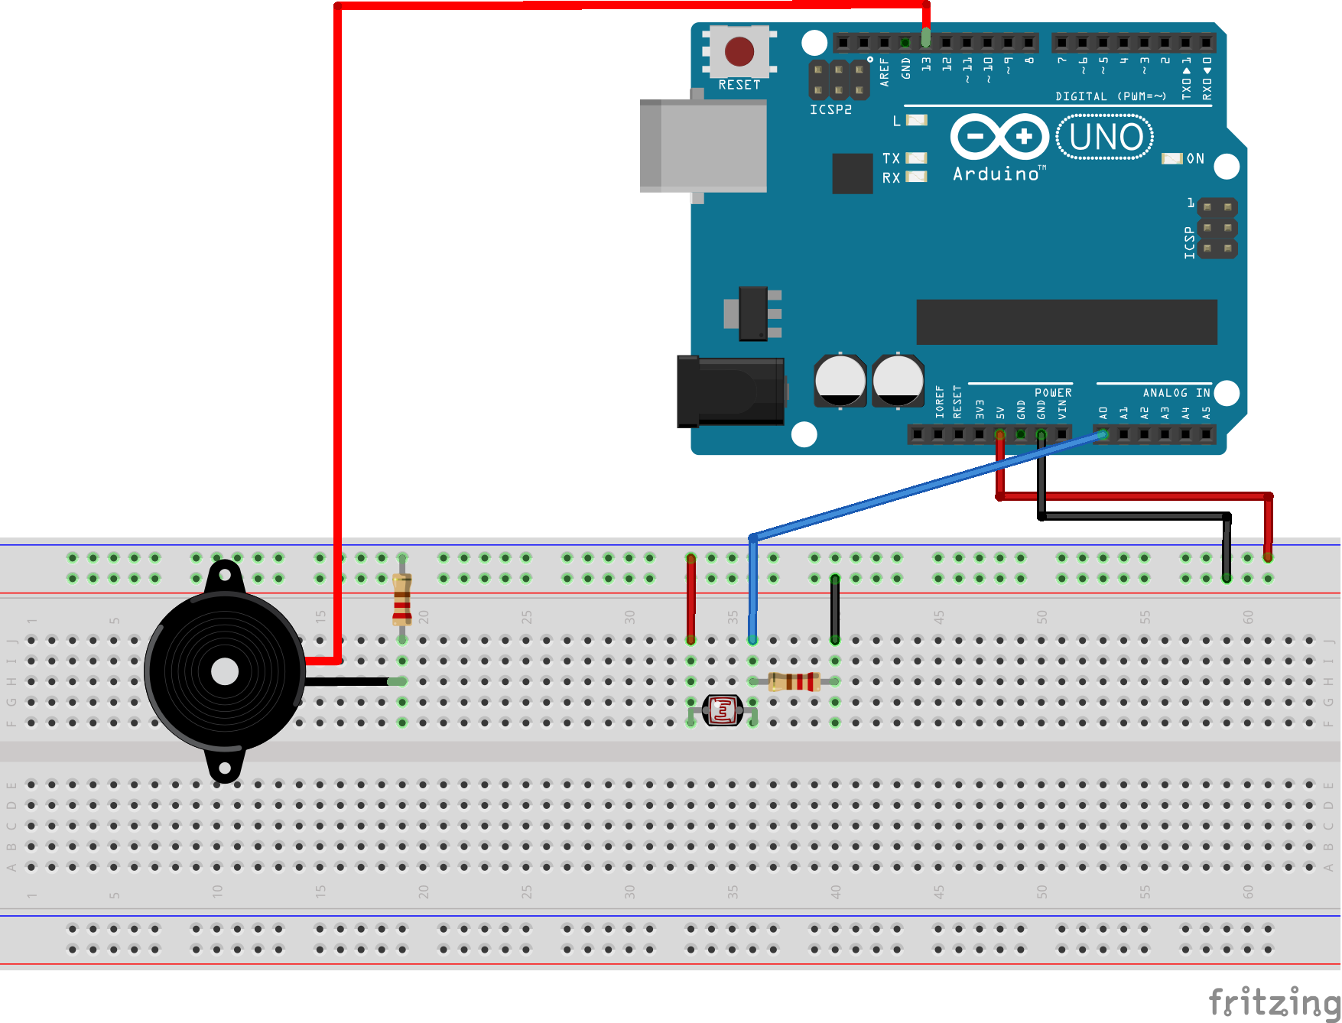

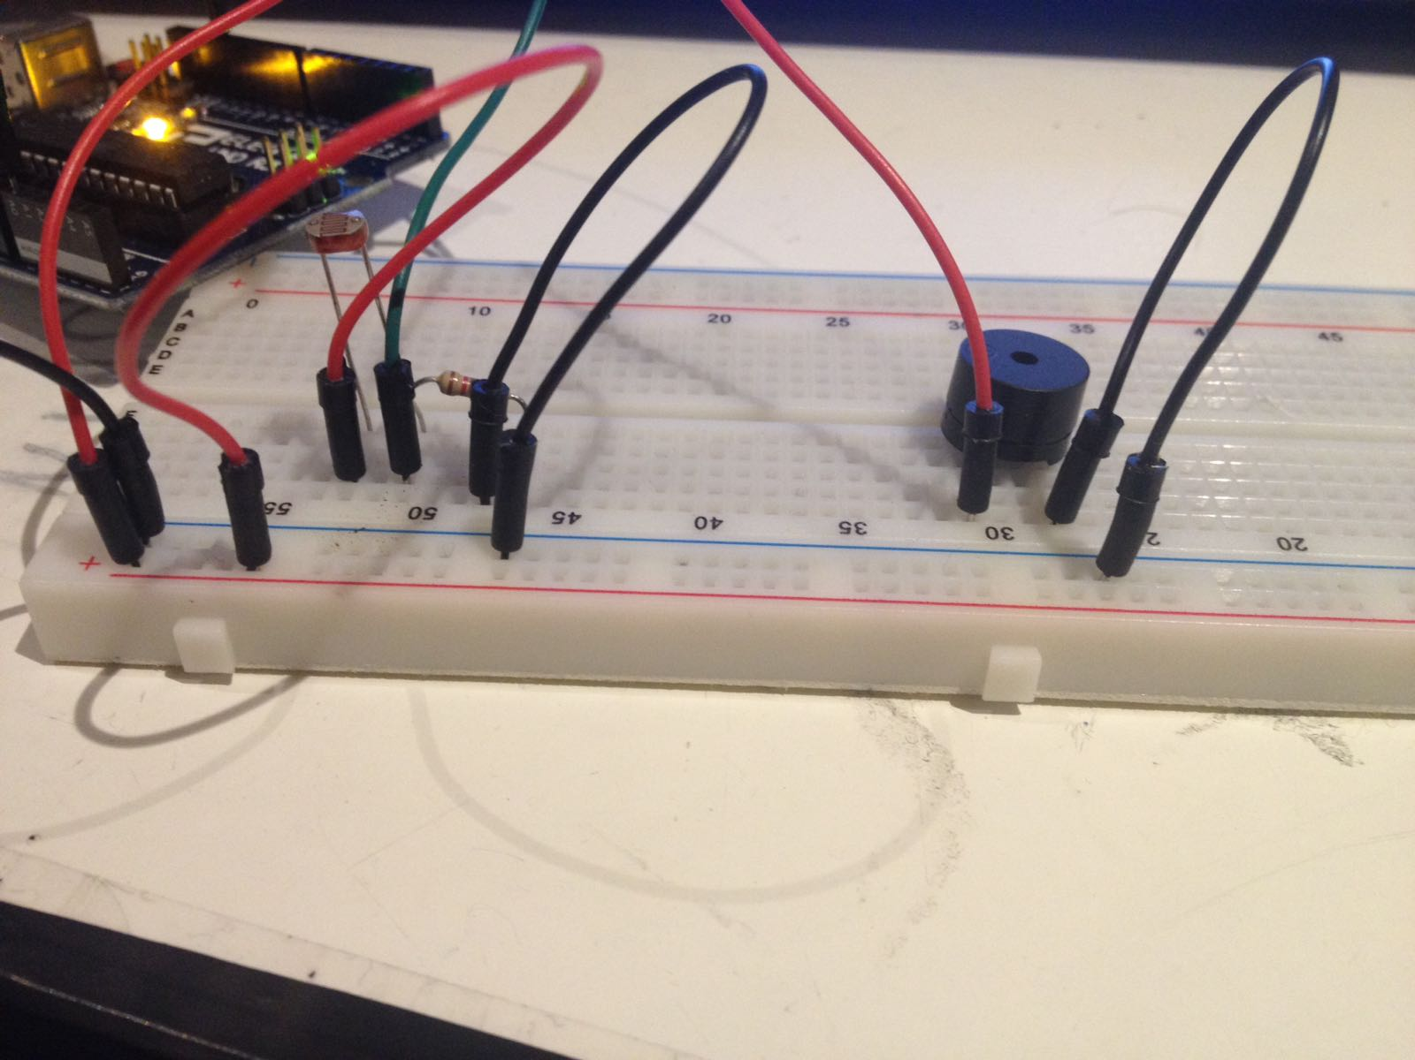

ARDUINO CODE:

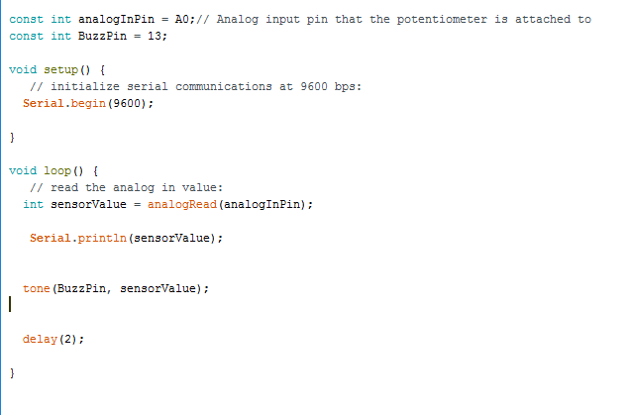

**Week Four**

**24/10/2016 :**

In this lesson we are going to be use Processing IDE as well as the Arduino one.  
Processing is an open source IDE, which makes Java and a lot of other programming languages easy to understand. It has its own native API (which belongs to the IDE itself), this can be used to draw primitives as well as reading datas from a certain port entry.  
The reason why we use this IDE is that, opening channel on a serial port it can listen to Arduino’s data, sent by the same serial port.

All datas passed need to be in bites so sometimes is a bit tricky, especially when it comes to send trough strings or large number (one byte can only contain an integer not bigger than the byte itself – 255).

It has been asked us to make something which could read an input from the Arduino and send it to Processing, the data would be then used for making something happen on the screen.

Modules and elements used:

-Two potentiometers 10k  
-Wires  
-Arduino and Processing

This is an easy circuit, but combining the two potentiometer values and assigning them to a circle x and y axis, we obtain curves and movement.

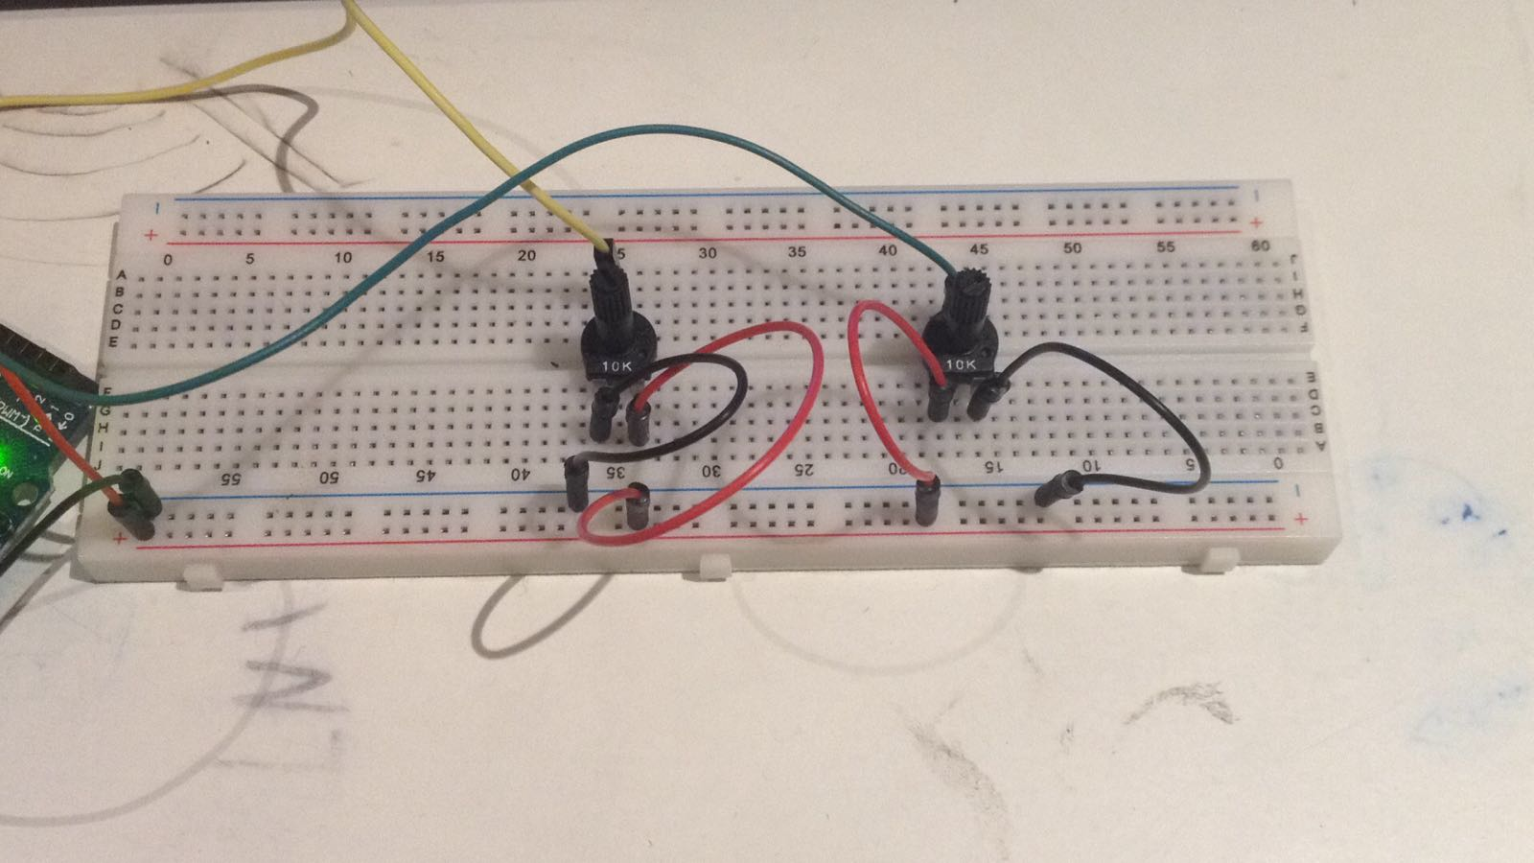

[CodeSnippet](Media/Arduino_Processing.PNG)-Picture

ARDUINO CODE

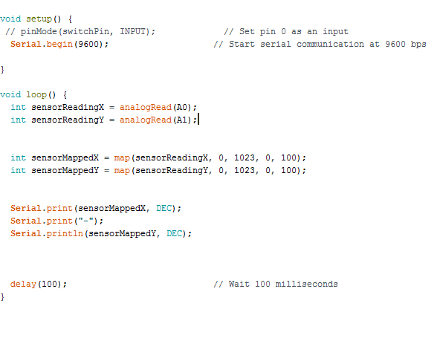

PROCESSING CODE:

*NOTE: Trickiest part is to get two different values!*

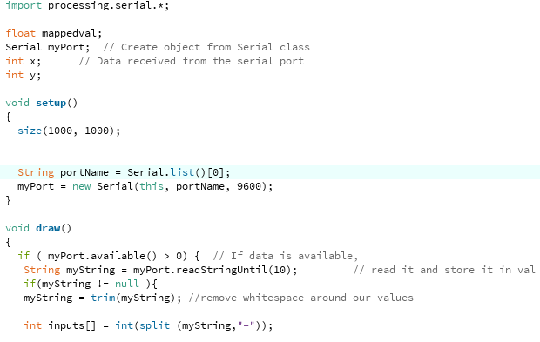

Convert from bytes to string and read until the endl sign, embedded in “printl”

Then split the string when the character “-“ appears

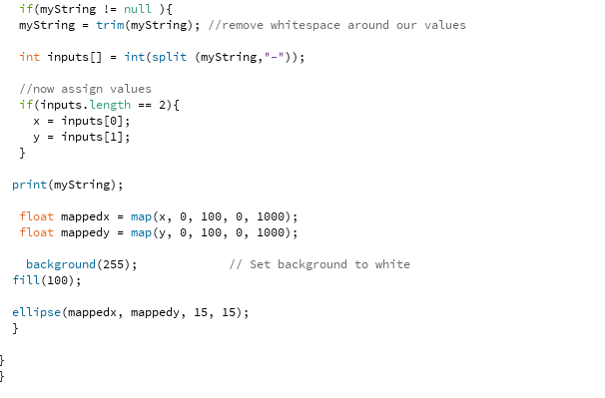

Store the two split parts in arrays

Map their range

Draw a circle consequently

VIDEO

**Week Five**

**31/10/2016 :**

In this lesson 3V motors and SERVO motors will become of use.  
These two elements are defined with the common word “motors”, this means they are both machines which can transform *electricity* *to* *energy*.

In our specific case these two elements transforms digital inputs from the Arduino to a rotary movement.  
If on one hand they are both motors and they solve the same task, on the other hand the task for them is quite different.  
The servo motor is in a way, a more precise motor. It is usually used in low powered circuit, where the main point is being able to suddenly change either speed or direction of rotation.  
The motor in fact has one digital exit, one for power and one for ground, this means that through the digital pin we can pass digits more precisely, preferring being accurate rather than powerful.

The 3V motor is just a basic motor, and has the common structure of a motor:

* Motors are powered by an electrically inducted magnetic field.
* This is achieved by induct current into a metal and possibly highly conductive object.
* The flowing current will generate magnetic field by let electrons in and giving them a direction and a “frequency”.
* Because this creates a south and a north pole, respectively for current out and in, if we then put the whole thing into a magnet, it will generate a constant rotation (as long as powered is supplied).

Motors need an external power supplier, but his can be controlled by the Arduino through a relay switch, which is made purposely for handling switch on current circuits.  
Note: Differently from the SERVO, in this case, the Arduino controls the relay switch and can only digitally write: either on (with controlled amount of power) or off.

Task 1:

Modules and elements used:

-Servo Motor  
-Potentiometer 10k  
-Wires

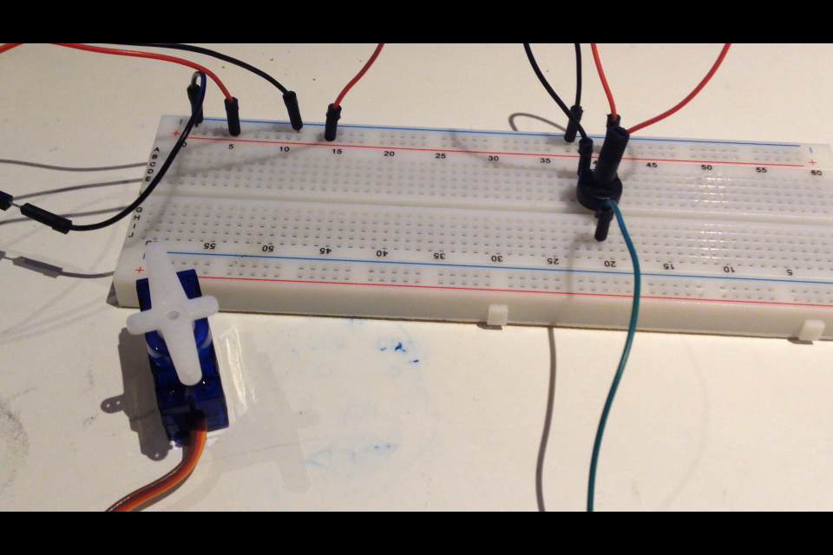

*Unluckily, my servo motor broke after this task, but I’ll still provide code and fritzing sketches.*

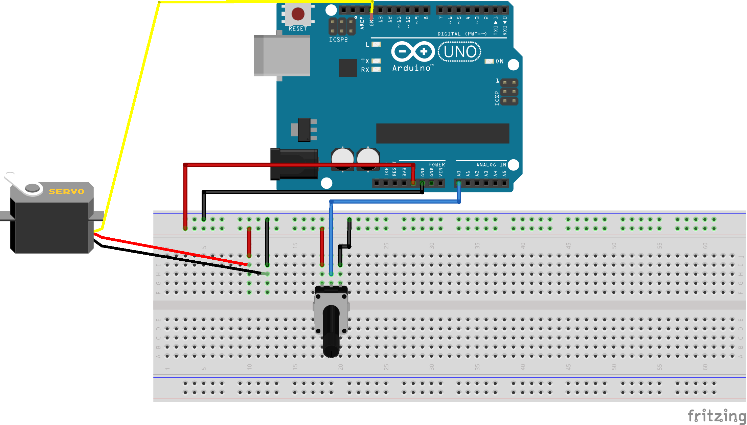

VIDEO  
  
NOTE: Arduino code is not really needed, there is plenty of examples for Servo, which needs maybe one or two variables to be changed and is good to work with potentiometer.   
The library for Servo is also quite intuitive and easy to catch...  
Plus I forgot to save or screenshot the code so I won’t be able to showcase it.

NOTE: Because I was absent during this lesson, to put motors in action, I’ve made up a little project involving some external elements as a diode and a transistor. My final achievement would be to have a switch between controllers and having the motor value handled by potentiometer and a photocell.

Task 2: Project “Pot_Phot_Mot”

Modules and elements used:

-Processing IDE  
-3v DC motor  
-external power supplier (5v)  
-resistor 10k  
-diode rectifier  
-relay switch  
-NPN transistor  
-potentiometer 10k

Step1 : Connect potentiometer and wire up the motor

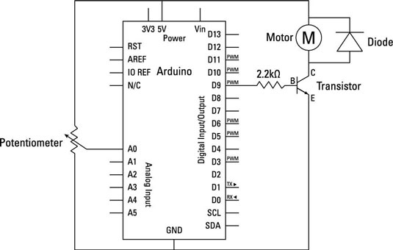

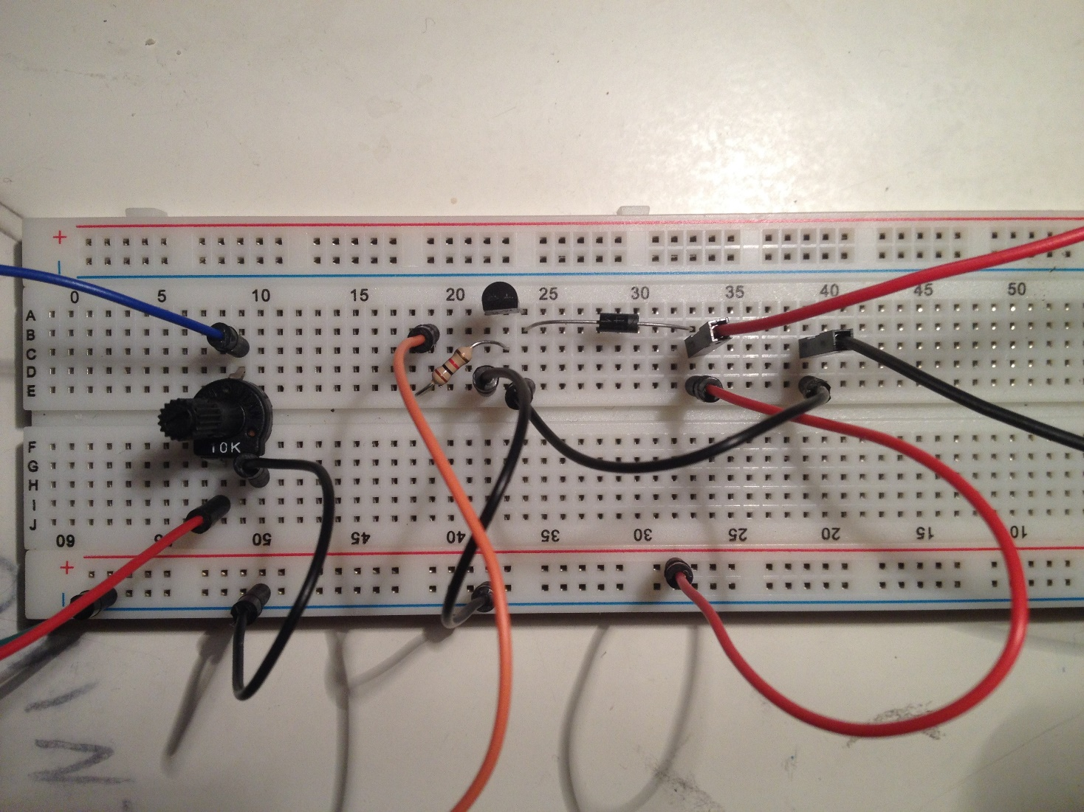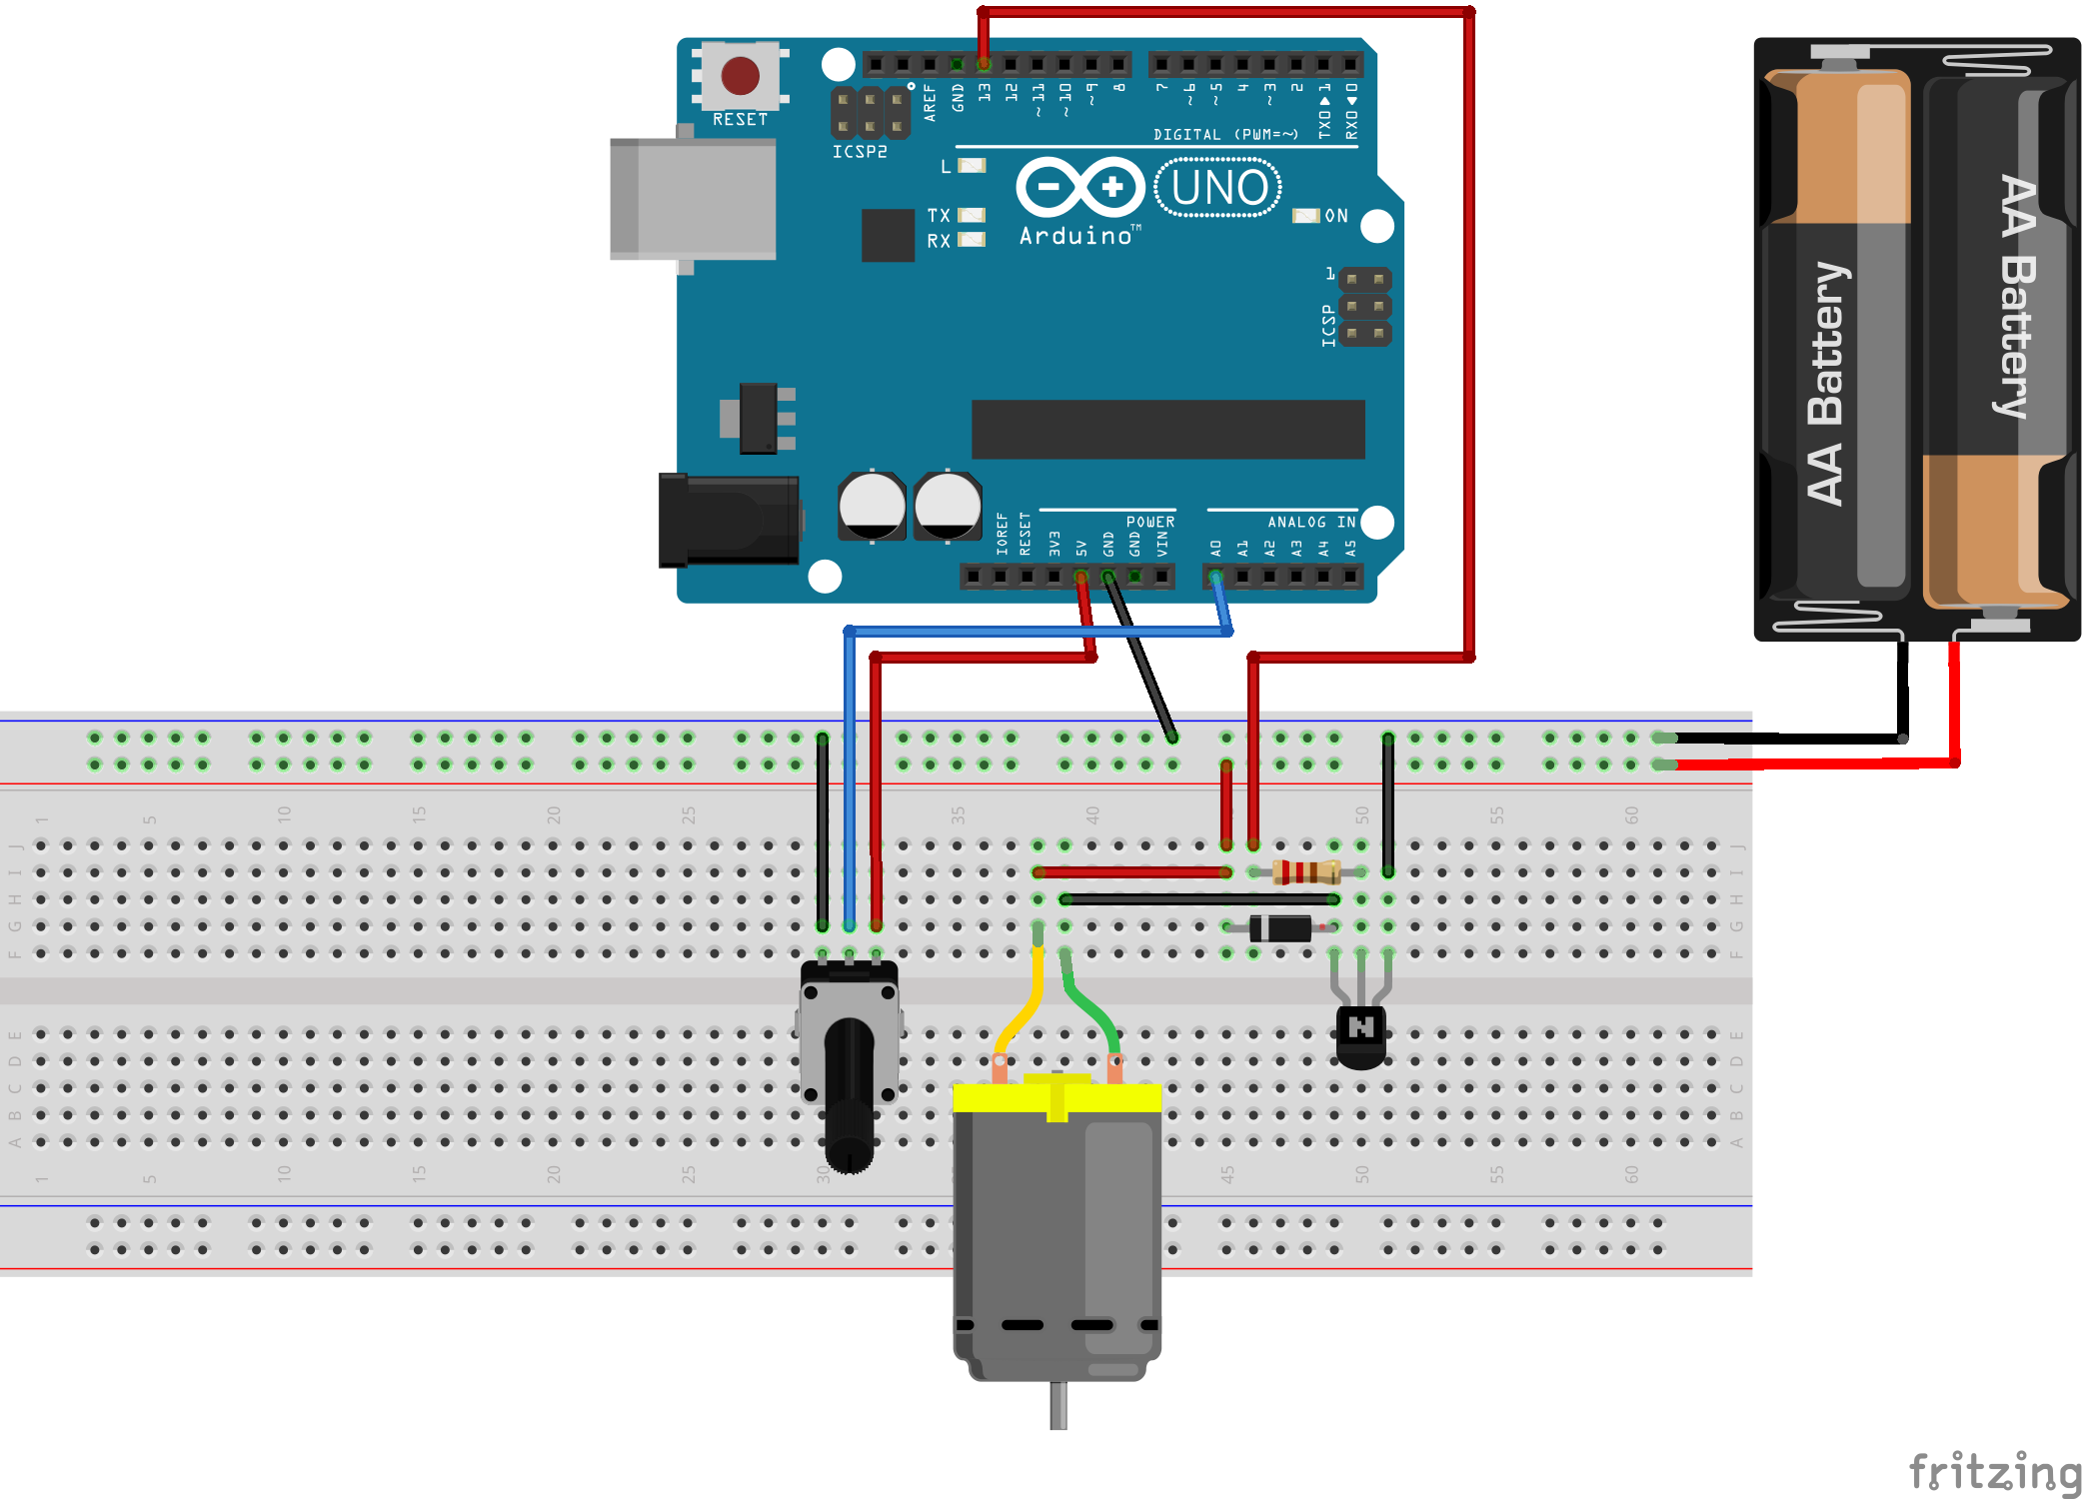

Legenda

ARDUINO CODE:  
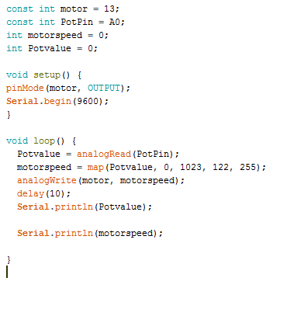

NOTE: *Read value from potentiometer, map it between 122 and 255 (which results to be the range of my motor).*

VIDEO

Step 2: Connecting to processing and exchanging data through serial.  
Once again, although the circuit could be considered nearly basic, handling data (especially when it comes to string and float) has been quite tough.

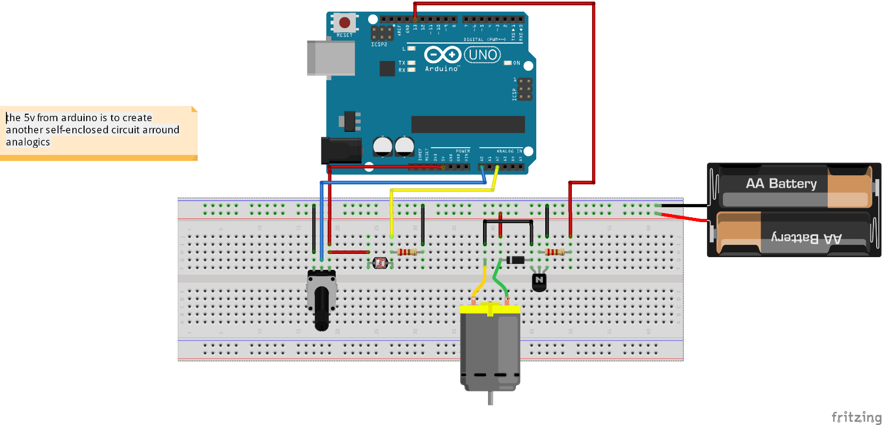

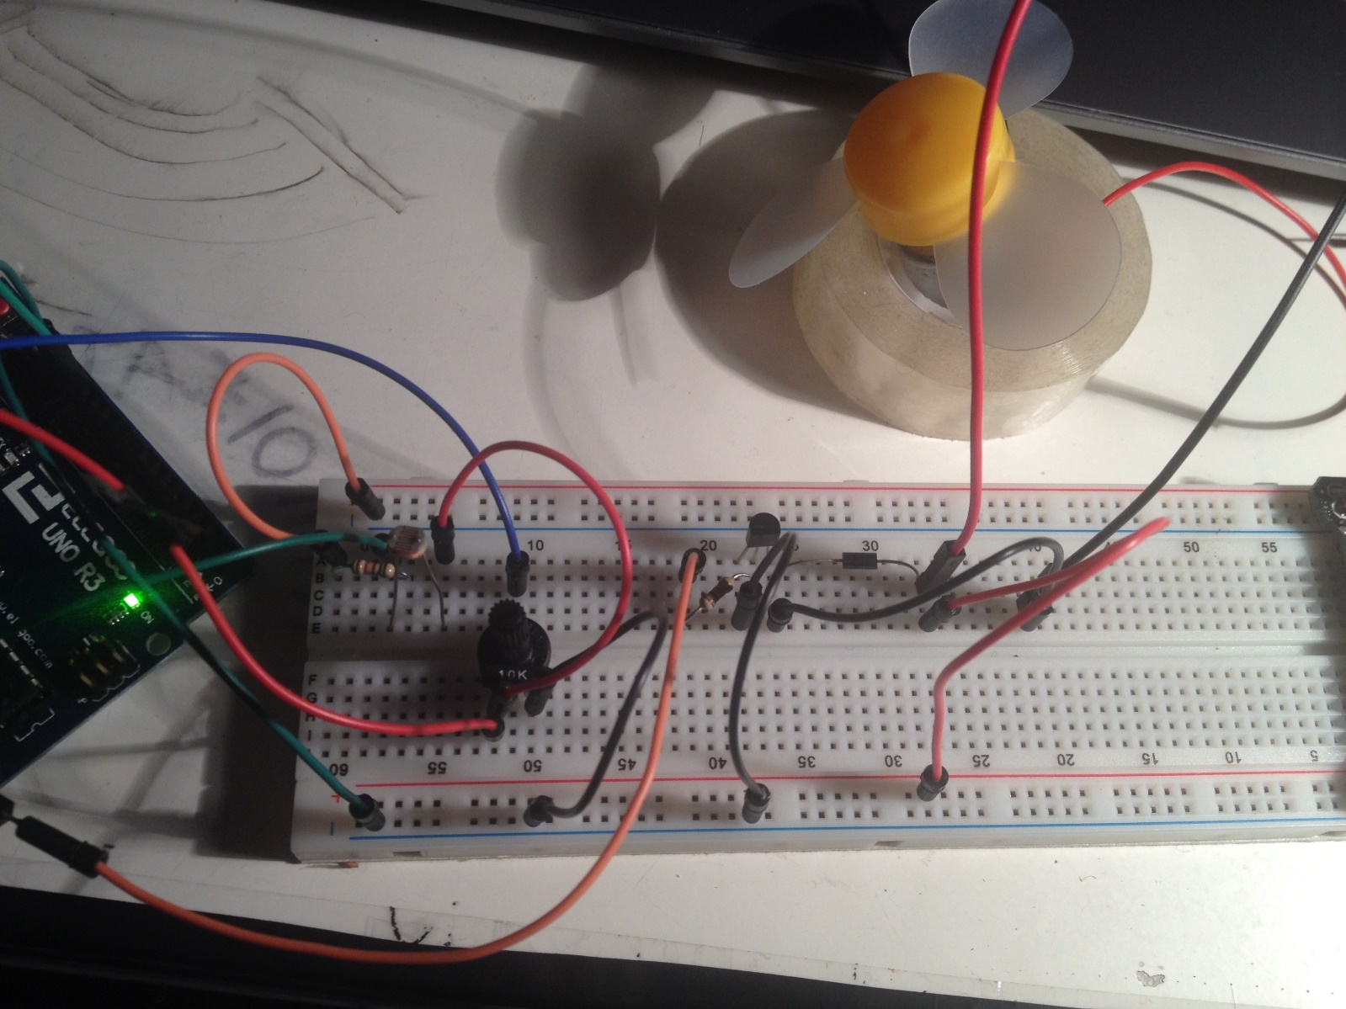

*NOTE: This Arduino sketch has been started from scratch*

ARDUINO CODE:

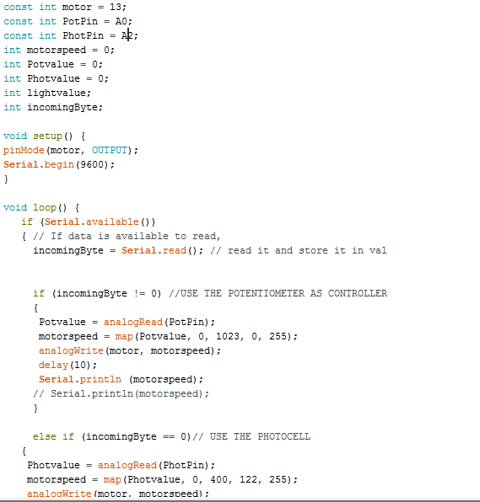

*NOTE: Arduino preferably takes in raw bytes, if a float or a big integer want to be stored it must be either split in different bytes or converted.*  
  
  
  
*NOTE: we use println and not print also for practical reason: it is an easier way to spot a new line character with no need to typing it*

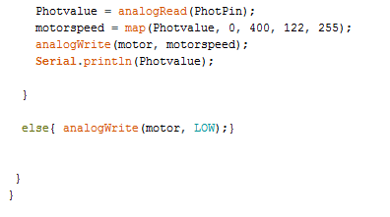

*NOTE: The following code is based on a uncompleted prototype found on a processing forum, all the implementation is mine*

PROCESSING CODE:

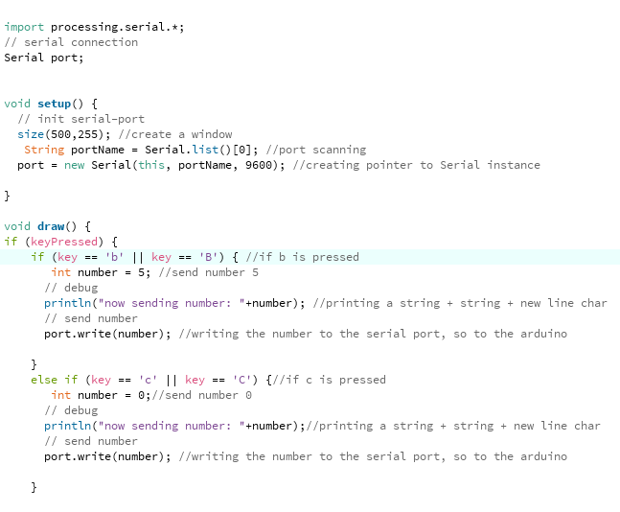

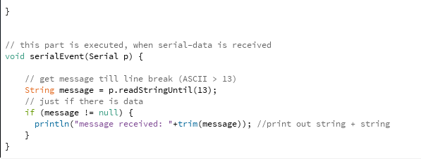

**Week Six**

**7/11/2016 :**

Morse code with two Arduino.

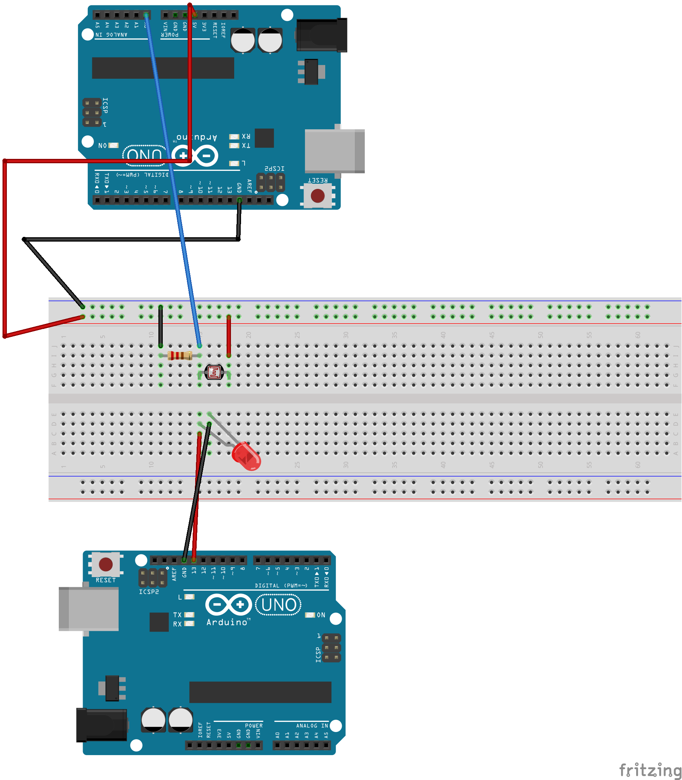

To read data

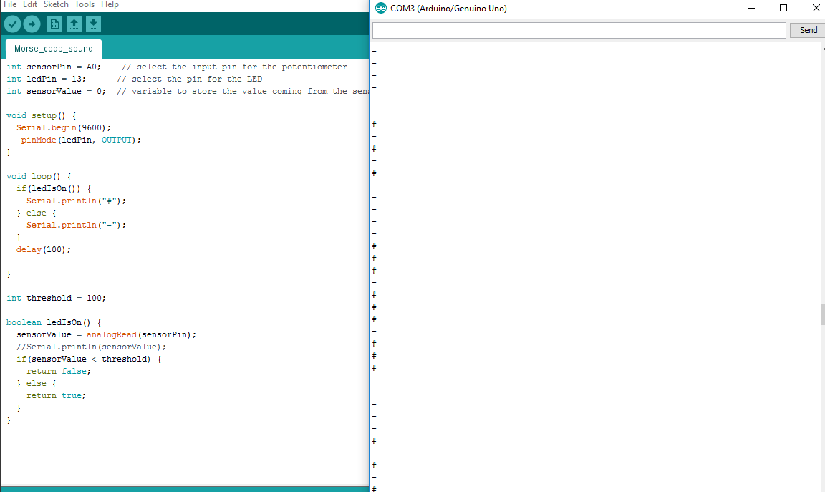

And to write data (blinking a led)

